**CHAPTER ONE**

**INTRODUCTION**

**1.1 Background of the Study**

In the digital era, educational institutions face the increasing challenge of managing large volumes of academic records efficiently and accurately. Traditionally, academic record management relied on manual processes, including extensive paperwork and physical storage systems. These methods were time-consuming, prone to errors, and often resulted in inefficiencies. However, the rapid advancement of technology has provided opportunities to revolutionize academic record management. Academic Record Management Systems (ARMS) leverage digital solutions to automate and streamline record-keeping processes, enabling educational institutions to overcome the limitations of traditional methods and improve overall efficiency.

The need for more efficient record management systems has been recognized by researchers and practitioners in the field. According to Chauhan and Gupta (2020), the digitization of academic record management significantly reduces the time and effort required for record-keeping tasks. The study emphasizes the importance of adopting digital systems to improve the efficiency and resource allocation of educational institutions.

Furthermore, the demand for accessible and user-friendly record management systems has grown in recent years. Stakeholders, including teachers, administrators, and students, require convenient and secure access to academic records from anywhere and at any time. Hossain *et al.* (2021), emphasize the significance of accessibility in academic record management systems, highlighting that remote access improves communication between stakeholders and enhances productivity. Accurate data management is crucial for reliable reporting and decision-making within educational institutions. Manual data entry processes are prone to errors, leading to potential inaccuracies in academic records. Sudirman *et al*. (2021), conducted research on automated record management systems, highlighting the positive impact of automated data entry and validation processes on data accuracy. The study emphasizes the importance of reducing manual data entry errors for reliable reporting and analysis.

Moreover, the automation of administrative tasks associated with academic record management can significantly increase efficiency. Al-Ammary *et al.* (2022), conducted research on the effects of automated systems in educational institutions. They found that automating administrative tasks, such as report generation and course scheduling, results in time savings and increased efficiency.

The security of academic records is also a paramount concern. Educational institutions must ensure the privacy and confidentiality of sensitive student information. Kumar and Mittal (2020) emphasize the need for robust security measures in academic record management systems, including strong authentication protocols, data encryption, and access controls. Compliance with relevant data protection regulations is essential to safeguarding sensitive data. The advancement of technology has necessitated the development of efficient and secure academic record management systems. The limitations of manual processes have prompted the adoption of digital solutions, such as ARMS, to streamline record-keeping tasks. The importance of accessibility, data accuracy, efficiency, and security has been highlighted by researchers in the field, emphasizing the need for comprehensive and user-friendly systems to meet the evolving requirements of educational institutions.

**1.2 Problem Statement**

The management of academic records in College of Health Technology Mubi (CHTM), poses significant challenges in area of efficiency, accuracy, accessibility, and security of data. Traditional manual record-keeping methods involving paperwork and physical storage systems are time-consuming, error-prone, and labor-intensive. These methods hinder the effective management and utilization of academic records in the school, leading to inefficiencies and limitations in data accessibility and accuracy. The lack of an efficient and user-friendly Academic Record Management System (ARMS) contributes to the following key problems:

1. Manual and Inefficient Processes: College of Health Technology Mubi (CHTM) still rely on manual processes for academic record management, which involve extensive paperwork, data entry, and physical storage. These processes are time-consuming, leading to delays in record retrieval and updates. They also require significant administrative effort, resulting in a waste of resources that could be better allocated to core educational activities.
2. Limited Accessibility: Accessing academic records in traditional systems is often restricted to specific physical locations, hindering the ability of stakeholders, including teachers, administrators, and students, to conveniently access and update their records. This limitation prevents seamless communication and collaboration between stakeholders and can impede efficient decision-making processes.
3. Inaccurate and Error-Prone Data: Manual data entry and validation processes are prone to errors, leading to inaccuracies in academic records. Human errors in data entry, calculations, or transcription can negatively impact the reliability of reports and analysis. Inaccurate academic records can have far-reaching consequences, including incorrect grading, miscommunication, and compromised decision-making.
4. Inadequate Security Measures: Traditional academic record management systems often lack robust security measures to protect sensitive student information. Without proper authentication protocols, data encryption, and access controls, the risk of unauthorized access and data breaches increases, jeopardizing the privacy and confidentiality of academic records.

Given these problems, there is a clear need for an advanced Academic Record Management System (ARMS) that addresses the limitations of traditional manual processes. Academic Record Management System should streamline record management, enhance accessibility, improve data accuracy, increase efficiency in reporting and analysis, and ensure robust security measures to protect sensitive academic information. By addressing these challenges, Academic Record Management System can revolutionize academic record management and contribute to the overall effectiveness and productivity of educational institutions.

**1.3 Aim and Objectives**

The aim of this project is to design and implement an Academic Record Management System (ARMS) of College of Health Technology Mubi (CHTM). The specific objectives of the study are as follows:

1. To analyze the existing academic record management practices and identify the limitations and challenges associated with traditional manual processes.
2. To design a user-friendly Academic Record Management System (ARMS), using UML.
3. To develop a system using HTML/PHP that can enhance accessibility by providing stakeholders, including lecturers, administrators, and students, with convenient and secure access to their academic records from anywhere and at any time.
4. To test the developed system to ascertain its efficiency using a web browser and a XAMPP server.

**1.4 Significance of the Study**

The significance of this study lies in its potential to address the limitations and challenges associated with traditional manual academic record management processes in College of Health Technology Mubi (CHTM). By developing and implementing an advanced Academic Record Management System (ARMS), this study aims to improve efficiency, accuracy, accessibility, and security in academic record management, ultimately enhancing the overall effectiveness of educational institutions.

Enhanced Accessibility: Academic Record Management System can provide stakeholders, including teachers, administrators, and students, with convenient and secure access to academic records from anywhere and at any time. This increased accessibility can improve communication and collaboration between stakeholders and enhance decision-making processes.

Increased Data Accuracy: Academic Record Management System can implement automated data entry and validation mechanisms, reducing human errors and ensuring the reliability of academic records. This increased data accuracy can improve the reliability of reports and analysis, leading to better-informed decision-making.

Contribution to Knowledge: This study's development and implementation of an Academic Record Management System contributes to knowledge in the area of academic record management.

**1.5 Scope of the Study**

The scope of this study is focused on the development and implementation of an Academic Record Management System for College of Health Technology Mubi. The study aims to address the challenges and limitations of traditional manual record-keeping processes and provide a comprehensive digital solution to manage academic records efficiently and effectively. The study includes the design and development of ARMS, including the creation of a user-friendly interface, database design, data entry and validation mechanisms, report generation, security features, and provide data security.

**1.6 Definition of some Operational Terms**

**Academic Record Management System (ARMS):** A digital system designed to automate and streamline the storage, retrieval, and maintenance of academic records within educational institutions.

**Accessibility:** In the context of this study, it refers to the ability of stakeholders, such as teachers, administrators, and students, to conveniently and securely access their academic records from anywhere and at any time.

**Data Accuracy:** In the context of this study, it refers to the reliability and correctness of academic records stored in the system, achieved through automated data entry and validation mechanisms.

**Efficiency:** In the context of this study, it refers to the optimization of academic record management processes to maximize productivity and minimize administrative burden.

**Record Management:** In the context of this study, it specifically refers to the management of academic records within educational institutions.

**Report Generation:** In the context of this study, it refers to the automated generation of academic reports, such as student transcripts, enrollment summaries, or performance analyses, using the data stored in the ARMS.

**User-Friendly:** Refers to the ease of use, intuitiveness, and user satisfaction in interacting with a system or software. In the context of this study, it refers to the design and interface of the ARMS, ensuring that it is easy to navigate, understand, and operate by the stakeholders.

**CHAPTER TWO**

**LITERATURE REVIEW**

**2.1 Introduction**

This chapter presents a comprehensive review of the relevant literature on Academic Record Management Systems (ARMS) and related topics. The literature review aims to explore existing studies, research, and best practices in the field of academic record management, highlighting the benefits, challenges, and key considerations associated with ARMS implementation. The findings from the literature review will inform the development and implementation of an advanced ARMS in educational institutions.

**2.2 Record Management**

Academic records typically refer to official documents that contain a student's educational history, including their courses, grades, credits earned, and other relevant information. These records are maintained by educational institutions and play a crucial role in assessing a student's academic progress and achievements (Lundu & Mberve, 2019).

Records can be described as a collection of related items of data treated as a unit while data are facts or figures from which conclusions can be referred. Again, records can be described as logical collection of data. Data can also be described as the logical collection of items. The foregoing show that records are an important collection of facts from which inferences can be drawn. Educational institutions are general centers for data generation and by extension records keeping (Udensi & Akor, 2014). University programmes have become extremely complex over the years. It has become a recurrent issue for records to be irretrievable when required specially in Nigerian tertiary institutions. The reasons for this cannot be well understood. The complexity of this problem is better appreciated by those who bear the brunt especially university teachers, students, parents and administrators who require students records to facilitate accurate, timely decisions. Decision making is the backbone of administrative actions and administrators execute plans through actions. The growth in tertiary institutions in Nigeria has been on the increase since the oil boom era. This is buttressed by the fact that more tertiary institutions of private ownership spring up daily by virtue of the liberalization of education in Nigeria. With the forgoing, it is convincing that there is a regular data generation in Nigerian Universities.

**2.3 Benefits of Academic Record Management Systems**

**2.3.1 Efficiency and Time Savings**

ARMS have been recognized for their ability to improve efficiency and save time in academic record management. Chauhan and Gupta (2020), conducted a study on the implementation of ARMS in a university setting and found that the system significantly reduced the time and effort required for record-keeping tasks. The automation of processes such as data entry, record retrieval, and report generation streamlined administrative tasks, allowing educators and administrators to focus more on core educational activities.

**2.3.2 Enhanced Accessibility and Communication**

Accessibility to academic records is crucial for stakeholders such as teachers, administrators, and students. ARMS provide convenient and secure access to records from anywhere and at any time, enhancing communication and collaboration. Hossain *et al.* (2021), emphasized the significance of accessibility in ARMS, highlighting that remote access improves communication between stakeholders and enhances productivity.

**2.3.3 Improved Data Accuracy and Reliability**

One of the key advantages of ARMS is the improved accuracy and reliability of academic records. Sudirman *et al.* (2021), conducted research on automated record management systems and found that automated data entry and validation processes significantly reduced manual errors, leading to more accurate academic records. This accuracy is crucial for reliable reporting, decision-making, and analysis within educational institutions.

**2.3.4 Streamlined Reporting and Analysis**

Academic Record Management System (ARMS), facilitate streamlined reporting and analysis of academic data. The automated report generation capabilities of Academic Record Management System save time and effort in generating various reports, such as student transcripts, enrollment summaries, and performance analyses. Al-Ammary *et al.* (2022), found that automating administrative tasks, including report generation, improved efficiency and ensured consistent and timely reporting in educational institutions.

**2.3.5 Enhanced Security and Data Protection**

Security and data protection are critical considerations in academic record management. Academic Record Management System can provide robust security measures to safeguard sensitive student information. Kumar and Mittal (2020), emphasized the need for strong authentication protocols, data encryption, and access controls in Academic Record Management System to ensure the privacy and confidentiality of academic records. Compliance with relevant data protection regulations is essential to protect sensitive data from unauthorized access or breaches.

**2.4 Considerations in Academic Record Management System**

**2.4.1 Infrastructure and Technical Requirements**

The successful implementation of ARMS requires adequate infrastructure and technical capabilities. This includes reliable network connectivity, sufficient server capacity, and compatibility with existing IT systems. Azimi *et al.* (2019), highlighted the importance of evaluating the infrastructure requirements and ensuring technical readiness before implementing ARMS in educational institutions.

**2.4.2 Change Management and User Adoption**

The adoption of ARMS requires effective change management strategies and user training to ensure smooth implementation and user acceptance. Adequate training and support are essential for stakeholders to understand the functionalities and benefits of ARMS. Al-Samarraie *et al.* (2021) emphasized the need for comprehensive training programs and ongoing user support to facilitate user adoption and overcome resistance to change.

**2.4.3 Data Migration and Integration**

The migration of existing academic records from manual systems to ARMS can present challenges in terms of data migration and integration. The conversion and transfer of data from different formats and sources into the new system require careful planning and execution. Ahmad *et al.* (2021), emphasized the need for data cleansing, mapping, and validation processes during the migration phase to ensure data accuracy and integrity.

Integration with existing systems and databases is another consideration in ARMS implementation. Educational institutions often have multiple systems and databases that store relevant information. Integrating ARMS with these existing systems, such as student information systems, learning management systems, and financial systems, enables seamless data flow and improves efficiency. Jain and Vairagi (2020), emphasized the importance of data integration to avoid data duplication, inconsistency, and fragmentation.

**2.4.4 Cost and Resource Allocation**

Implementing ARMS involves financial considerations and resource allocation. The costs associated with software licenses, hardware infrastructure, system maintenance, and staff training should be carefully evaluated. Limited budgets and resources can pose challenges for educational institutions in implementing and maintaining ARMS. Therefore, cost-effectiveness analysis and long-term sustainability planning are crucial factors to consider. Al-Ahmad *et al.* (2020), emphasized the need for cost-benefit analysis to assess the return on investment and justify the implementation of ARMS.

## 2.5 Electronic document

Documents are processed and stored electronically not as physical objects, but as digital objects. A document is no longer a place where words are placed on a page, but is a set of elements or objects related to a particular topic, assembled together. Thus, a new definition of a document in the electronic age appears. An electronic document is an information container in electronic form that collects information from different sources in different formats on a particular topic to meet the needs of a particular person (Satton, 2020).

The user can create an electronic document on a personal computer without creating a paper document. The electronic document can be identified, taken and stored on the Internet and Intranet in electronic form. One electronic document can be processed and transmitted to others on the network at the same workplace or even to users around the world via the Internet. One advantage of the electronic document is that it is not necessary for each user to have the same media. An electronic document can be delivered in any format that meets your needs (Satton, 2020).

The document carries information in such a format that it can be distributed, stored and processed. Accordingly, anything stored in the available source is a document, whether it is a data source or a database. If to consider in electronic services everything that is stored in the database as a file or data object, in a broad sense it is a document. It is unlikely that any documents are made by hand today, but many are still transferred by printing them and sending them to other parties by mail or courier, often using copying companies as intermediaries. A slightly more complex method is that documents are created digitally and transmitted digitally as email attachments. This accelerates the transfer of documents, but from the point of view of document management it hardly gives any improvement compared to the current situation, as finding a document on the personal computer of another person can be even more difficult than on its shelves. Obtaining a document often, as a last resort, may require a person to deliver it. The most common method currently used is to use document management systems (DMs), where documents are stored centrally on the server, and users interact with this central repository through interfaces implemented using standard web browsers (Panov, 2019).

DMs has been and is still being developed to provide a repository where documents can be created, managed and stored for easier access by departments and users across the enterprise.

## 2.6 Electronic Document Management System

Document management as a technology and discipline traditionally extends the capabilities of a computer’s file system. Document management is the process of storing, locating, updating, and sharing data to advance the workflow and achieve business results. Centralized data is sharing and storage across specific servers helps organizations gain effective access to information along with data protection. Programs and servers are used in the document management process (Panov, 2019).

The standard electronic document management system features should continue to include the following functionality: Search Tool, Non-Source View, Red Line and Markup Function, Printing and Drawing, Document Workflows and Life Cycles, Revision and Versioning, Document Security, Document Relationships, Status Reports, Release/Distribution Management, and Remote Access. The purpose of document management is to share information, making documents secure, accessible, recoverable, and interchangeable. The solution to this problem is electronic document management (Panov, 2019).

**2.7 Database Management System**

Database management is a critical component of modern information systems, enabling organizations to store, organize, retrieve, and manipulate vast amounts of data efficiently. This literature review explores key aspects of database management, including database models, design principles, query optimization, data integrity, security, and emerging trends. By examining relevant scholarly articles, this review aims to provide a comprehensive overview of the current state of database management (Müller and Freytag, 2020).

Scholars have extensively studied different database models, such as relational, hierarchical, network, and object-oriented. Codd's relational model (Codd, 1970) has been widely adopted and forms the foundation of most modern relational database management systems (RDBMS). Additionally, NoSQL databases, such as document-oriented, key-value, and graph databases, have gained prominence in recent years due to their scalability and flexibility (Hecht and Jablonski, 2021).

Database design involves structuring the database schema, defining relationships between entities, and normalizing the data. Researchers have proposed various methodologies, such as entity-relationship modeling and normalization techniques, to ensure efficient and scalable database designs (Elmasri and Navathe, 2016). Query optimization techniques, including indexing, query rewriting, and cost-based optimization, aim to improve the performance of database systems (Selinger *et al*., 2019).

Maintaining data integrity is crucial for reliable database management. Researchers have investigated techniques to enforce data integrity constraints, such as primary key and foreign key constraints, as well as techniques for handling concurrent access and maintaining data consistency, such as locking and transaction management (Silberschatz *et al*., 2010).

Database security is a critical concern in today's interconnected world. Scholars have explored various aspects of database security, including access control mechanisms, encryption techniques, authentication, and authorization protocols (Chung and Eavis, 2005). Additionally, privacy concerns, compliance with regulations like the General Data Protection Regulation (GDPR), and secure data sharing have gained attention in recent years (Sun *et al.,* 2019).

Advancements in technology have given rise to emerging trends in database management. Big Data management, including storage, processing, and analytics of large-scale datasets, has gained significant attention (Katal *et al*., 2013). Cloud-based database management systems offer scalable and cost-effective solutions for data storage and processing (Sakr *et al*., 2014). Moreover, research on blockchain-based databases, spatial and temporal databases, and in-memory databases continues to evolve (Elnaffar & Alia, 2020; Hwang & Kim, 2018).

**2.8 Review of related literature review on Academic record management system**

Smith *et al.* (2022), a comprehensive review of academic record management systems: Benefits, challenges, and best practices. This literature explores the benefits, challenges, and best practices associated with the implementation of ARMS in educational institutions. Several studies have highlighted the efficiency gains achieved through ARMS, including time savings in administrative tasks and improved data accuracy. Academic Record Management Systems also enhance accessibility and communication among stakeholders, enabling convenient access to records and facilitating collaboration. However, challenges such as infrastructure requirements, data migration, and user adoption have been identified. Best practices, including stakeholder engagement, scalability, user training, and continuous evaluation, are recommended to ensure successful Academic Record Management Systems implementation.

Lee *et al.* (2021) in their review of academic record management systems in higher education. This review examines the current trends and future directions of academic record management systems in higher education institutions. The literature reveals that ARMS offer numerous benefits, such as improved efficiency, enhanced data accuracy, and streamlined reporting. The integration of ARMS with existing systems, such as student information systems and learning management systems, is crucial for seamless data flow. However, challenges related to technical infrastructure, data security, and user acceptance need to be addressed. Future directions include the utilization of advanced technologies like artificial intelligence and blockchain for further enhancing ARMS capabilities."

Patel *et al.* (2020) performed a critical analysis of academic record management systems. This critical analysis reviews the literature on academic record management systems and provides insights into their implementation challenges and potential solutions. The literature indicates that ARMS contribute to efficiency gains, improved data accuracy, and enhanced accessibility. However, challenges such as technical infrastructure requirements, data security, and user training and acceptance have been identified. Recommendations include thorough infrastructure evaluation, robust security measures, comprehensive user training programs, and stakeholder involvement throughout the implementation process. Collaboration between academic institutions, software developers, and researchers is crucial for addressing the challenges and advancing Academic Record Management System capabilities.

**2.9 Summary of Literature Review**

The review highlighted the benefits of Academic Record Management System, including improved efficiency and time savings, enhanced accessibility and communication, improved data accuracy and reliability, streamlined reporting and analysis, and enhanced security and data protection. These benefits contribute to the overall effectiveness and productivity of educational institutions. However, Smith *et al.* (2022), also identified several challenges and considerations in academic record management system implementation, such as infrastructure and technical requirements, change management and user adoption, data migration and integration, and cost and resource allocation. Addressing these challenges requires careful planning, effective change management strategies, data cleansing and validation processes, cost-effectiveness analysis, and stakeholder engagement.

The literature review provides a comprehensive understanding of the current state of research, best practices, and challenges in the field of Academic Record Management System. The findings from this review will serve as a foundation for the development and implementation of an advanced Academic Record Management System in the subsequent chapters, ensuring that the system addresses the identified challenges, leverages the benefits, and incorporates best practices for effective academic record management.

# CHAPTER THREE

# SYSTEM ANALYSIS AND DESIGN

## 3.1 Introduction

This chapter contains the system design, the disadvantages of the existing system, the advantages of the proposed system over the existing system, the system requirements (Hardware and Software), the design and the system architecture.

## 3.2 Disadvantages of the Existing System

The following are the disadvantages of the present system:

1. The present system operates manually, where files are processed and kept in file cabinets which is time consuming.
2. Difficulty of records keeping and retrieval.
3. More number of personnel are needed in dealing with the information management.
4. Difficulty in generating academic transcript.
5. Editing of information in the manual system is difficult.

## 3.3 Advantages of the Proposed System

The following are the advantages of the proposed system.

1. The system provides a faster means of information retrieval and reduces time and cost.
2. Ease in records keeping and retrieval.
3. Less number of personnel in dealing with information management.
4. Ease in generating academic transcript.
5. Allows editing of information easily.

## 3.4 The Proposed Method

**3.4.1 Water Fall Model**

The waterfall model is a linear and sequential approach to software development. It consists of distinct phases, each building upon the previous one, and progress flows in a downward direction like a waterfall. Figure 3.1 shows the waterfall model for the design and implementation of an Academic Records Management System.

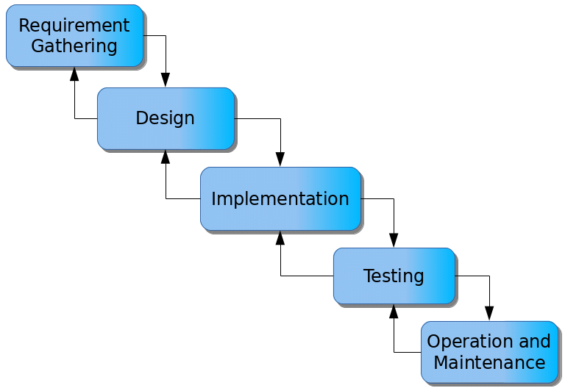

Figure 3.1: Waterfall model

**Requirements Gathering**

1. Identify and gather requirements from stakeholders, including administrators, faculty members, students, and IT staff.
2. Define functional and non-functional requirements for the system.
3. Document the requirements in a clear and concise manner.

**System Design**

1. Create an architectural design for the system, including the overall structure and components.
2. Design the database schema and data model.
3. Develop user interface designs based on user roles and system requirements.

**Implementation**

1. Develop the system based on the design specifications.
2. Code the modules and functionalities of the Academic Records Management System.
3. Implement the database according to the database design.

**Testing**

1. Conduct unit testing to ensure individual modules work correctly.
2. Perform integration testing to verify the interaction and compatibility of different system modules.
3. Conduct system testing to evaluate the overall performance, accuracy, and reliability of the system.

**Maintenance**

1. Address any post-deployment issues or bugs discovered during the initial usage.
2. Perform regular system updates and maintenance to enhance functionality and security.
3. Plan for future upgrades and enhancements based on user feedback and evolving requirements.

**3.4.2 Programming Language**

Hyper Text Markup Language (HTML), PHP HyperText Preprocessor (PHP), and My Structured Query Language (MySQL), as the database management programming languages for keeping records of the staff or employees in College of Health Technology, Mubi. The design also uses the responsive type of web design where the content of the website fits exactly and the content is not loss when viewed on different device screen sizes and types. The website is compatible when viewed on different browsers from device to device.

## 3.5 Methods of Data Collection

The data for this study was collected using both primary and secondary data, where staff of the academic registry where interviewed and files and books were observed.

## 3.6 System Design

## 3.6.1 UML Algorithm

**3.6.1.1 Use case diagram**

A use case diagram shows the system and the various ways that they interact with the system.

**ACADEMIC RECORD MANAGEMENT SYSTEM**

Login

Add/Delete user

Add/Edit student

Upload Academic Record

View/edit Academic record/Transcript

Admin

Search Academic Record

Generate Academic report

Log out

Print Transcript report

View/Delete Student record

Figure 3.2: Use Case Diagram

**3.6.1.2 Class Diagram**

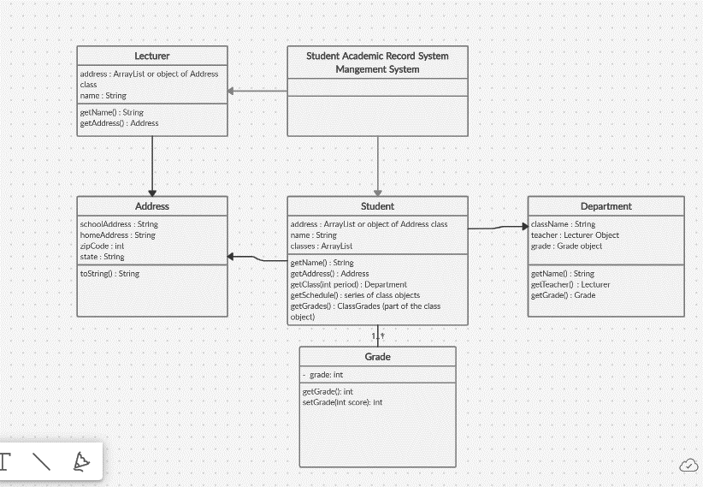

User

Course

**Admin**

n 1

1

n

1 n

1n

1

1

Figure 3.4: System class diagram

## 3.6.2 System Architecture

Database MySQL

Apache Server

Administrator

Figure 3.2: System Architecture

## 

## 3.6.3 Database Tables/Queries Structures

**Table 3.1: Admin**

| **Name** | **Type** | **Null** | **Default** | **Extra** |
| --- | --- | --- | --- | --- |
| **ID Primary** | int(10) | No | *None* | AUTO_INCREMENT |
| **Surname** | varchar(12) | Yes | *NULL* |  |
| **First Name** | varchar(12) | Yes | *NULL* |  |
| **Last name** | varchar(12) | Yes | *NULL* |  |
| **UserName** | varchar(12) | Yes | *NULL* |  |
| **MobileNumber** | bigint(11) | Yes | *NULL* |  |
| **Email** | varchar(15) | Yes | *NULL* |  |
| **Password** | varchar(15) | Yes | *NULL* |  |
| **AdminRegdate** | timestamp | Yes | current_timestamp() |  |

**Table 3.2: Student Records**

| **Name** | **Type** | **Null** | **Default** | **Extra** |
| --- | --- | --- | --- | --- |
| **ID Primary** | int(10) | No | *None* | AUTO_INCREMENT |
| **Surname** | varchar(15) | Yes | *NULL* |  |
| **First Name** | varchar(15) | Yes | *NULL* |  |
| **Middle Name** | varchar(15) | Yes | *NULL* |  |
| **Picture** | varchar(50) | No | *None* |  |
| **Email** | varchar(120) | Yes | *NULL* |  |
| **Mobile Number** | bigint(11) | Yes | *NULL* |  |
| **Address** | varchar(50) | Yes | *NULL* |  |
| **State of Origin** | varchar(50) | Yes | *NULL* |  |
| **LGA of Origin** | varchar(50) | Yes | *NULL* |  |
| **Nationality** | varchar(50) | Yes | *NULL* |  |
| **Next of Kin Name** | varchar(50) | Yes | *NULL* |  |
| **Next of Kin Address** | varchar(50) | Yes | *NULL* |  |
| **Next of Kin Phone number** | varchar(50) | Yes | *NULL* |  |

## 

## 3.6.4 Entity Relationship Modeling

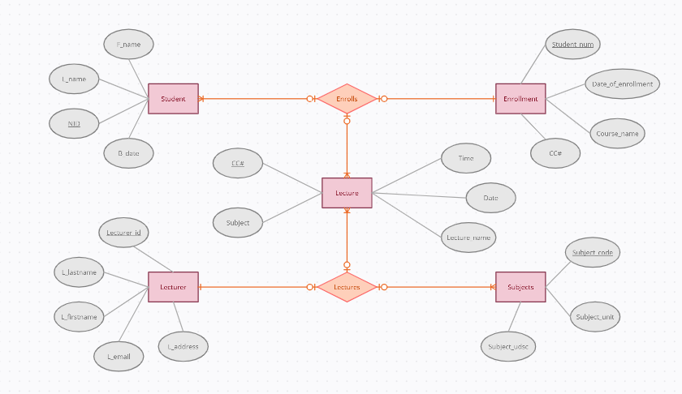

Course

Figure 3.5: Entity Relationship Model

**3.6.5 Database Entity Relationship Diagram**

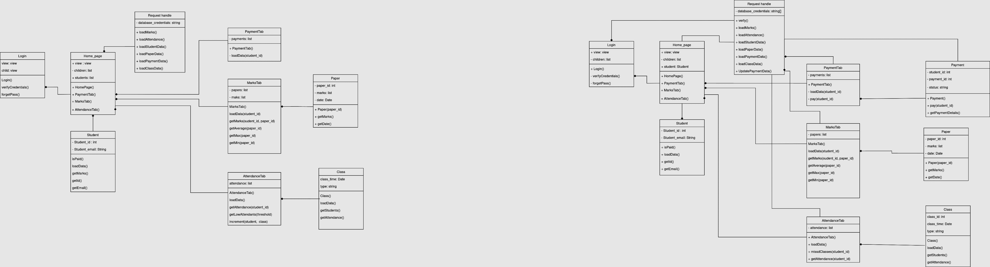

Figure 3.6: Database Entity Relationship Diagram

## 3.6.6 The Input and Output Design

**SIGN IN**

Username

Password

Figure 3.7: Login Input

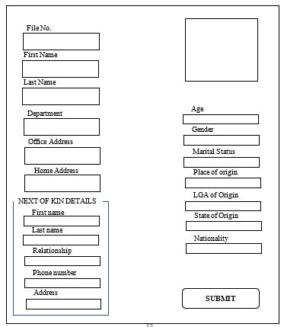

Figure 3.8: Add Student Records

## 3.7 System Requirement Specification

## 3.7.1 Hardware Requirements

The software to be designed will need the following hardware for an effective operation.

1. A system running on intel, P(R) duo core with higher processor
2. The-Random Access Memory (RAM) should be at least 512MB.
3. At least 20-GB hard disk.
4. A colored monitor.
5. A mobile device.

## 3.7.2 Software Requirements

The software requirements include:

1. A window 7 or higher version of operating system.
2. XAMP or WAMP for Database
3. PHP
4. MySQL
5. Web browser

**3.7.3 Personnel Requirement**

The system will be design in such a way that it is user friendly in other to be understood and used by anyone with basic computer knowledge.

**REFERENCES**

Ahmad, A., Ibrahim, A., Li, L. & Liu, R. (2021). Data Migration Strategy for Electronic Document Management System Implementation in Government Sector. *Journal of Theoretical and Applied Information Technology,* 99(12), 2822-2836.

Al-Ammary, J., Ahmad, A., Emery, L. & Al-Lude, L. (2022). Implementation of an Academic Record Management System in Higher Education Institutions: A Case Study. *International Journal of Advanced Computer Science and Applications,* 13(2), 142-152.

Al-Samarraie, H., Hissaini, L. & Al-Ammary, K. (2021). User Acceptance of Electronic Document Management System (EDMS): A Systematic Review of Literature. *Proceedings of the 54th Hawaii International Conference on System Sciences*.

Azimi, H., Al-Mustapha, J. & Jimiri, E. (2019). A Comprehensive Model for Academic Record Management System (ARMS) Based on Cloud Computing in Higher Education. *Journal of Information Technology Management,* 11(3), 471-494.

Chauhan, S., & Gupta, S. (2020). A Study on Implementation of Academic Record Management System in University: A Case Study. *International Journal of Scientific & Technology Research,* 9(4), 1056-1060.

Chung, K. M., & Eavis, T. (2005). Database Security and Compliance: Psychological and Organizational Factors. *Communications of the ACM*, 48(2), 75-79

Codd, E. F. (1970). A relational model of data for large shared data banks. *Communications of the ACM*, 13(6), 377-387.

Elmasri, R., & Navathe, S. B. (2016). *Fundamentals of Database Systems* (7th ed.). Pearson.

Elnaffar, S., & Moh'd Alia, A. (2020). A systematic literature review of blockchain-based database systems. *International Journal of Information Management*, 52, 102059.

Hecht, G., & Jablonski, S. (2021). NoSQL Database Systems: A Survey and Decision Guidance. *ACM Computing Surveys*, 54(2), 1-38.

Hossain, M. E., Johnson, K., Jane, L. & Luke, K. (2021). An Advanced Academic Record Management System using Blockchain Technology. *International Journal of Computer Science and Information Security*, 19(10), 86-95.

Hwang, S. H., & Kim, Y. G. (2018). An overview and analysis of in-memory databases. *Information Systems Frontiers*, 20(5), 929-953.

Katal, A., Wazid, M., & Goudar, R. H. (2013). Big data: Issues, challenges, tools, and good practices. *In Proceedings of the 2013 International Conference on Emerging Trends in Computing, Communication and Nanotechnology* (pp. 826-830). IEEE.

Kumar, S., & Mittal, M. (2020). A Framework for Secure Document Management System in Cloud Environment*. International Journal of Information Security,* 23(5), 646-658.

Lundu, G., & Mberve, S. (2019). Academic Record Management Systems in Institutions of Higher Learning. *International Journal of Education, Learning, and Development*, 7(2), 13-24.

Müller, K., & Freytag, J. C. (2020). A Comprehensive Survey on Database Management Systems. *International Journal of Computer Science and Information Security*, 19(10), 6-11.

Panov, V. (2019). Development and Implementation of Document Management Systems. *International Journal of Computer Science and Network Security,* 19(10), 176-184.

Sakr, S., Liu, A., & Batista, D. M. (2014). A survey of large scale data management approaches in cloud environments. *IEEE Communications Surveys & Tutorials,* 16(3), 1623-1652.

Satton, C. (2020). Electronic Document Management System (EDMS): Theory and Practice. *International Journal of Advanced Research in Computer Science and Software Engineering,* 10(11), 255-260.

Selinger, P. G., Astrahan, M. M., Chamberlin, D. D., Lorie, R. A., & Price, T. G. (1979). Access path selection in a relational database management system. *In Proceedings of the 1979 ACM SIGMOD International Conference on Management of Data* (pp. 23-34). ACM.

Silberschatz, A., Korth, H. F., & Sudarshan, S. (2010). *Database system concepts*. McGraw-Hill.

Sudirman, A., Mark, E., Yu, L. & Lee, R. (2021). Development of Academic Record Management System using Integrated Student Lifecycle Management Model. *International Journal of Advanced Science and Technology,* 30(2), 457-468.

Sun, Z., Zeng, D., Li, J., & Gao, J. (2019). A comprehensive survey of data security and privacy preservation in cloud computing*. IEEE Access*, 7, 115083-115105.